DIS-PAC-POLY-Samoa-Tattoos

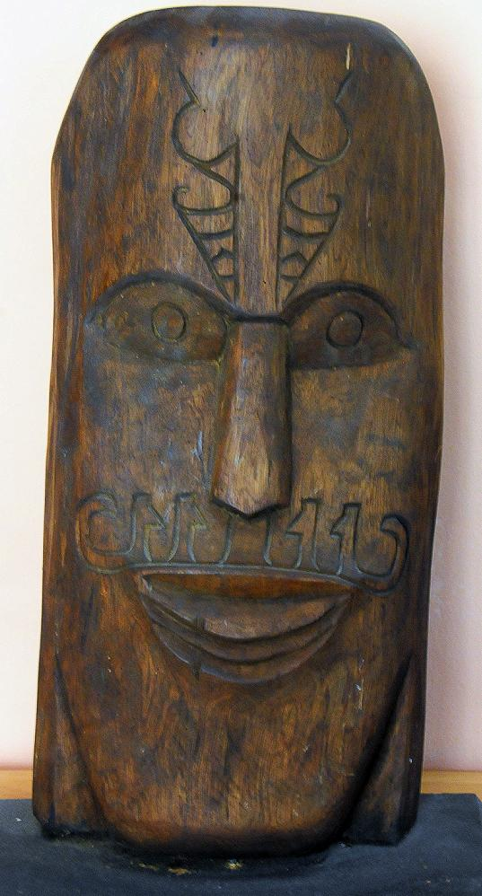

Fig. 1. Wooden bust (koa wood?) of a Samoan *ali’i* with extensive facial tattoos.

Samoan tattoos have their origin in the two-thousand year-old Polynesian culture. Both men’s (*pe’a*) and women’s tattoos (*malu*) are executed by "*taula-aitu*" or healers using teethed combs made of human bone attached to a turtle shell that protects the "*taula-aitu*" from the power of the human bone. The combs are dipped in ink, that was originally applied only to people of rank or *ali’i.* In 1899 almost all the Samoan men and 60-70 per-cent of the women are tattooed (Marquart 1899). These tattoos carry encoded invocations on behalf of the health of the individual involved. Explications of these encoded symbols were collected by a German anthropologist in Samoa, Carl Marquart (1899), and can be used to interpret the current tattoos on the wooden bust above.

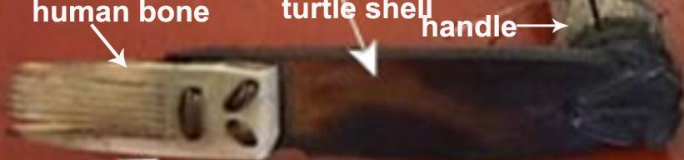

Fig. 2. Tattooing device used in Samoa.

Receiving a *pe'a* or *malu* is still considered a rite of passage, a symbol of reaching manhood or womanhood in Samoa, a process that can take days and even weeks to complete. Assistants sharpen the combs, prepare the ink, and apply the designs that have been received by the applicant in divine inspiration. In other words the tattoo symbols are an expression of the essence of the individual or his/her mission.

In the wooden bust under consideration Samoan symbols have been applied to the face.

The black tree fern (*Cyathea medullaris*), which reaches 20 m., and which is called In Samoa *’oli ’oli* (Milner 1993: 453) is distributed across the southwest Pacific from Fiji to Pitcairn and New Zealand. The salient feature of this plant is that it has spirally-unfolding emergent fronds suggestive of emergent life and protection from harm.

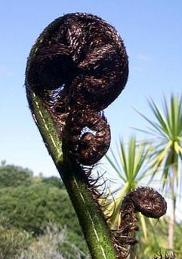

 Fiddlehead of a Black Tree Fern (*Cyathea medullaris*).

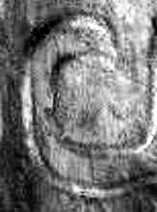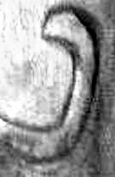

Spiral elements of the Samoan bust related to the fronds of the tree fern.

As worn by warriors it represents an apotropaic or protective symbol to avert harm. This symbol is used in conjunction with the symbol for shark teeth or sharp weapons.

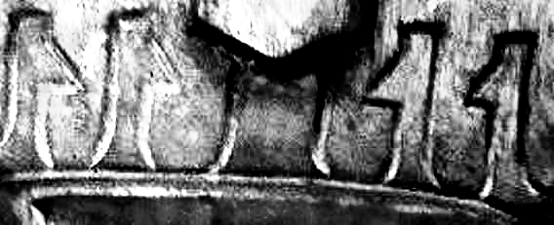

The combined symbolism suggests “protection from sharp weapons [of an enemy]”.

The symbolism on the forehead is consistent with this interpretation.

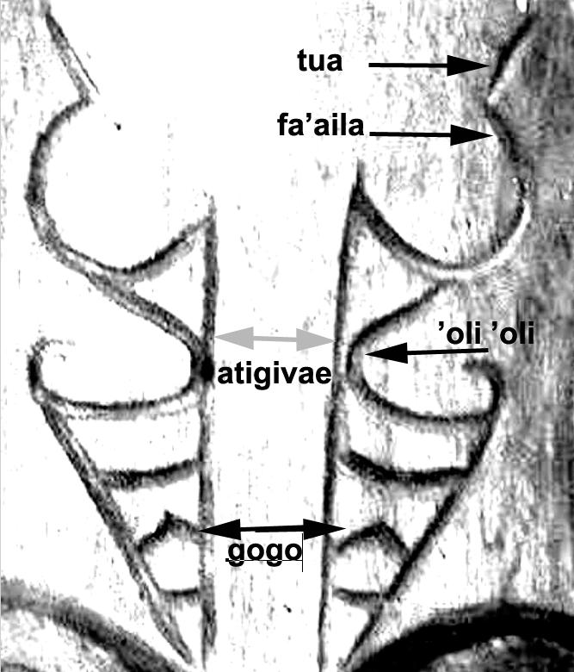

*tua*  back

*fa’aila* birthmark

*atigivae* claw

*’oli ’oli* tree-fern frond = life, protection

*gogo* sea bird

The combined tattoo symbolism on the forehead suggests, “The birthmark on [my] back is similar to the protection provided by a sea bird’s claw”. It reinforces the twin values that lie at the heart of Polynesian culture: strength in the face of death and the ability to tolerate extreme amounts of pain.

If this interpretation of the tattoos on the forehead of this Samoan *ali’i* is correct then the symbolism of the birthmark is defined as a protective sign, which is consistent with the interpretation of the apotropaic symbolism of the tree fern tattoos on his lips.

References:

# Marquart, Carl. 1899. *Die Taetowirung beider Geschlechter in Samoa.* Berlin: D Reimer.

Milner, G. B. 1993. *Samoan Dictionary: Samoan-English, English –Samoan*. Auckland, Aotearoa-New Zealand: Polynesian Press.

*Pe'a* is an ancient art that preserves critical symbols of Polynesian culture and shows what these peoples value: in this case, strength and the ability to tolerate extreme amounts of pain. The pe'a represents a tradition in which the language of symbols speaks volumes.

According to the mythology, the 2 sons of the God of Creation Ta’aroa taught the art of tattooing to humans. It was a tapu or sacred art form. It was performed by shamans (*tahua*) who were highly trained in the religious ritual, the meaning of the designs and technical aspects of the art.   
The designs and their location on the body were determined by one's genealogy, position within the society and personal achievements.  
In preparation for the tattooing, one would have to undergo a period of cleansing. This generally involved fasting for a specified length of time and abstaining from sexual intercourse or contact with women.  
Dr. ROLLIN described the art of tattooing the following way: “The patient was immobilized most frequently in a sort of vise composed of two trunks of banana trees between which he was attached and held tight. The tattooer, accompanied by his assistants, sang a sort of chant of the occasion syncopated to the rhythm of the tapping of his little mallet. Each drop of blood was rapidly wiped up with a scrap of tapa, so that none be allowed to fall to the ground”. (Note: the tapa is a piece of cloth made out of the bark of a tree beaten with a heavy stick).

Tattooing was begun at adolescence. Teenagers (around 12 years) were tattooed to mark the passage between childhood and adulthood. Different tattoos were added with the passing of years. The more a man was tattooed, the more prestige he had.   
Tattooing was not only a sign of wealth, but also a sign of strength and power. Therefore chiefs and warriors generally had the most elaborate tattoos. Men without any tattoo were despised, whereas those whose bodies were completely tattooed – the *to’oata* – were greatly admired

**The South Seas**

Archeologists can't prove (as armchair historians claim) that the Polynesian tattoo tradition goes back to the Ma'ohi civilization more than a thousand years ago. In the hot and humid tropics where the soil is acidic, organic matter (corpses especially) decays rapidly. Of the hundreds of thousands of people who have lived in Tahiti, the Marquesas, Samoa, and the other Polynesian Islands, very few skeletal remains have been found. What we have is the somewhat less perishable oral tradition -- mythologies, songs, and ritual ceremonies that depict how the two sons of the Tahitian Creation God, Ta'aroa, instructed the people in the sacred art of 'tatatau'. We can only assume that the ancient tattoos resembled the motifs seen in Tahiti's tattoo revival, many of the designs from which were recovered from the journal entries of traders and missionaries who visited the South Seas from the late 18th century onwards. Common design elements included geometric motifs, petroglyphs, and simple depictions of men, animals, birds and other objects. Tattoos were applied by shamans, who, along with the young male inductee, underwent cleansing rituals that involved fasting and segregation from women. These designs represented a personal history, one's island of origin, social status, or work. Or it protected against sharks and enemies. Certain mystical symbols incorporated a spiritual force called mana, which, while emanating from ancestors, remained for the individual to develop and master. As in Borneo, this spiritual power was displayed in and through the tattoo. To be without the tattoo was to be truly naked. Although the Polynesians never had a written language, their tattoos have been called a 'language of the skin'. French writer, Michel Tournier, who reversioned Robinson Crusoe, says:

"Polynesian tattoos are also language, but primary, primordial, original language. Tattooed, the body becomes a body-sign. It is a book of spells scrawled upon the skin, it is knowledge and initiation." (Introduction to Tahiti Tattoos, Taschen Books.)

Raymond Graffe, the "fire-walking, Harley-Davidson-riding high priest of Tahitian tattooing," (who is also an archeologist at the Ministry of Culture), explains that "these tattoos were meant to enhance sexual attraction, to exalt the life force and to give the wearer a godlike appearance." (Tahiti Tattoos.) Girls were tattooed earlier than boys, but the young men continued to add to their collection until they reached the age of about thirty. The names of these tattoos, and the tattoo process itself was revived in the modern era by referring to the Samoan tattoo tradition, which is unique among Polynesian cultures for its unbroken history of tattoo practices - in the face of the censures of Christian prohibition.

Samoans appeared to have adopted Christianity as a ploy to get the white man's god on their side. After all, this god to whom they prayed had blessed these Europeans with ships that could survive a journey half way around the world. But the Samoans saw Christianity as an add-on, not a replacement for beliefs that had served them for as long as anyone could remember. Lacking evidence to date the origins of the Samoan tattoo, we are left to consider its importance to the culture. Filmmaker, Robert Flaherty, was the first to film the extensive tatau operation in 1925, and his wife's journal sheds light on the social role it had played for up to 2,000 years.

"To the Samoan man, it is the crucial event in a lifetime, from which all other happenings are dated. Until he is tattooed, no matter how old he may be, the Samoan man is still considered and treated as a boy. Tattooing is the beautification of the body by a race who, without metals, without clay, express their feelings for beauty in the perfection of their own glorious bodies. Deeper than than, however, is its spring in a common human need, the need for struggle and for some test of endurance, some supreme mark of the individual worth and proof of the quality of the man... What is it that can keep alive the spirit of man but his own respect for what he is, the God that is within him? And so it is that tattooing stands for valor and courage and all those qualities in which man takes pride."

The traditional Samoan pe'a tattoo covered the man's body from mid-torso to the knees, and was inked so intensely that from a distance it appeared as a solid blue garment. The tattooist used a mallet to tap-tap-tap the teeth of an ink-infused comb into the flesh. This was an extremely painful trial of manhood, but to quit before completion was to be forever marked as a coward. From first puncture to final healing could take a year. Women took hand tattoos and designs on the thigh and genital area called malu, a less intense product than the pe'a, but no less spiritual.

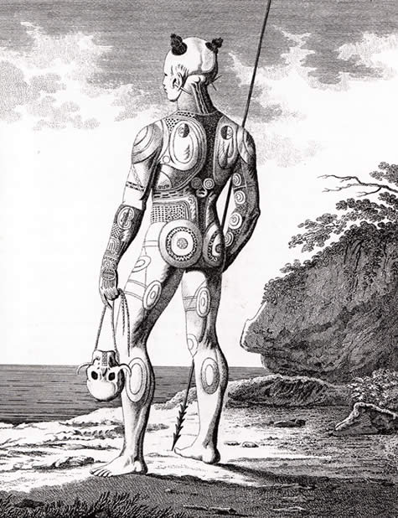

Nowhere in Polynesia - or the world, for that matter - was tattooing taken to the extremes that it was in the Marquesas Islands. For almost two thousand years, Polynesians built up a rich and highly decorative culture on these remote volcanic islands in the Pacific, of which tattooing was (arguably) the most significant aspect. Marquesan men of wealth and rank were boldly tattooed from head to foot in a process that wouldn't be completed until late in life. In the late 19th century, under French military rule, Marquesan tattooing was officially prohibited, and all but disappeared. Early European visitors (including Herman Melville) made detailed notes of the elaborate tattoos before they started to vanish. G.H. Von Langsdorff, circumnavigating the globe under the Russian banner (1803-1807) made these observations:

"...curved lines, diamonds and other designs, are often distinguishable between rows of punctures... The most perfect symmetry is observed over the whole body; the head of a man is tattooed in every part; the breast is commonly ornamented with a figure resembling a shield; on the arms and thigh are stripes, sometimes broader, sometimes narrower, in such directions that these people might very well be presumed to have studied anatomy, and to be acquainted with the course and dimensions of the muscles. Upon the back is a large cross, which begins at the neck, and ends with the last vertebrae. In the front of the thigh are often figures which seem intended to represent the human face. On each side of the calf of the leg is an oval figure which produces a very good effect. The whole, in short, displays much taste and discrimination. Some of the tenderest parts of the body, the eyelids for example, are the only parts not tattooed." (from: Tattoos From Paradise, by Mark Blackburn, 1999)

Since Marquesans were an agricultural people living in their separate valleys, anthropologists have speculated that their tattoos may have been of tribal significance. And once again, the question arises - where did the designs first appear - on their wooden implements and temples - or as tattoos? No answer has yet been substantiated. During a 1921 expedition to the Marquesas, a tattoo inventory by Willowdean Handy concluded that these tattoos were for show - on hands when a woman kneaded dough and ate her poipoi, under arms when a warrior raised his war club, on chest and arms when a man promenaded with his arms behind his back. Marquesans seem to have made a show of their tattoos equal to the sartorial displays of people in northern climes with their designer fashions.

Polynesians in New Zealand, having arrived in the 'Land of the Long White Cloud' a mere thousand years ago (a theory that ignores Maori folklore, by the way), developed a complex culture that featured both fine clothing and tattoos. What most distinguished these islanders was their moko, spiral-based designs on the face that were, in most cases, chiseled into the skin. There's no consensus on the significance of the facial markings, but the most popular schools of thought suggest that the moko was a badge of distinction and a personal signature that told of proud events in one's life. It may have identified one's tribe, status, and personal line of descent. How far back this extreme form of body modification goes, isn't known, but it may not be so ancient. Only in the late 18th century did the etched designs replace the traditional Polynesian tattoo methods in New Zealand's more populated North Island. However long the moko has been around, it was - and still is - worn with pride.

"You may lose you most valuable property through misfortune in various ways... your house, your weaponry, your spouse, and other treasures. You may be robbed of all that you cherish. But of our moko, you cannot be deprived, except by death. It will be your ornament and your companion until your final day."  
  
(Netana Whakaari of Waimana, 1921)

**Tattoo, Tatau, Tatatau**

Through modifying their skin, the ancients were conveying messages about the values the tribe held in common, the traditions, myths, and philosophy of the group. Body art was an organic facet of primitive man's social and aesthetic outlook and to his relationship with the natural and the supernatural world. As Captain Cook's 1769 expedition set sail for home, his crew must have been profoundly moved by their first-hand experiences with this radical worldview. Along with their cargo of breadfruits, plantains and coconuts, they were importing to the West a brand new word for the English lexicon -- 'tattoo'.

For 250 years, the word was associated with sailors and a host of transients, misfits, and mavericks. Despite British admiralty (even royalty) acquiring tattoos, the tradition in the West hasn't until recently gained the kind of respect necessary to open minds to an appreciation of tattoo history and the spiritual role of tattoos going back all the way to ancient times.